WORKSHOP #4
Fractals

Abstract. The concept of iteration is introduced in a historical context as an algebraic method for approximating square roots. Geometric iteration is then used to investigate the Cantor set, the Sierpenski Gasket, the Devil’s Staircase and the Koch Snowflake. At that point the workshop participants move to the computer lab to investigate the many fractal resources on the web.

The fractal pictured below appeared in the very interesting article
Tomorrow’s weather: Cloudy, with a chance of fractals
by Robert Matthews in
New Science issue 2733, November 4, 2009

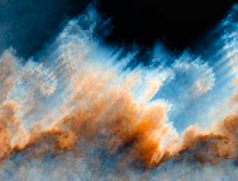

FRACTALS

What is a fractal?

American Heritage Dictionary

A geometric pattern that is repeated at ever smaller scales to produce irregular shapes and surfaces that cannot be represented by classical geometry. Fractals are used especially in computer modeling of irregular patterns and structures in nature.

[French, from Latin fractus, past participle of frangere, to break; see fraction.]

Wikepedia

A fractal is generally a rough or fragmented geometric shape that can be split into parts, each of which is (at least approximately) a reduced-size copy of the whole, a property called self-similarity. The term was coined by Benoit Mandelbrot in 1975 and was derived from the Latin fractus meaning broken or fractured. A mathematical fractal is based on an equation that undergoes iteration, a form of feedback based on recursion.

What is iteration?

American Heritage Dictionary

1. The act or an instance of iterating; repetition.

2. Mathematics: A computational procedure in which a cycle of operations is repeated, often to approximate the desired result more closely.

3. Computer Science:
a. The process of repeating a set of instructions a specified number of times or until a specific result is achieved.

b. One cycle of a set of instructions to be repeated: After ten iterations, the program exited the loop.

Let's consider an old example of mathematical iteration for approximating square roots. This idea was used by Sumerian mathematicians some 4000 years ago.

Sumer was an ancient country of southern Mesopotamia in present-day southern Iraq. Archaeological evidence dates the beginnings of Sumer to the fifth millennium B.C. By 3000 a flourishing civilization existed, which gradually exerted power over the surrounding area and culminated in the Akkadian dynasty, founded c. 2340 by Sargon I. Sumer declined after 2000 and was later absorbed by Babylonia and Assyria. The Sumerians are believed to have invented the cuneiform system of writing.

The Sumerian method for approximating square roots is sometimes called the \lq Babylonian method\rq and sometimes \lq Heron's method\rq after Heron of Alexandria who gave the first explicit description of the method.

For example, suppose we want to find The square root of 2 is irrational so we won't be able to calculate it exactly as the quotient of two integers. However, as we shall see, we can find highly accurate rational approximations of it.

In the following, keep in mind that so . The Sumerian method is basically a guess and try method. So we start by making a guess for r, call the guess x. If the guess is right on the nose, i.e. x=r, then . But probably our guess will be either too large or too small. If our guess is too large, i.e. x>r, then . That is, if x>r, then . Similarly, if x<r, then . Again, we see that r falls between x and , so the average of these values, , should be an even better estimate for r. Now start over with this better estimate and repeat or iterate the process. The approximations calculated in this way get closer and closer to We say they converge to

Let's apply this method to the problem of approximating with an initial guess of 2.

The average of 2 and is .
What is the next estimate if the initial guess is 1?
Repeat the process, using as the estimate for . What is the next approximation?

That's correct, the second iterate is
The third iterate is
The third iterate is already quite close to . In fact, differs from 2 by

The same reasoning applies as well to for any a>0. The method can be stated in the form of an algorithm.
Let a>0 be given. Let x₀ be an initial estimate for .

For calculate
This is actually a quite remarkable algorithm. Even with a lousy initial approximation, the algorithm produces a sequence that converges to . Of course, it breaks down if 0 is given as the initial approximation. But if a negative number is given initially, it simply produces a sequence of negative numbers that converge to -.

Moreover, the algorithm is easy to use. For any positive number a, we may produce a sequence of better and better approximations to 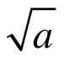 on a TI calculator by carrying out the following steps:

1. (your first approxomation) STO → X

2 (X + a/X)/2 STO → X

Repeatedly pressing the enter key will give ever better approximations to .

The Sumerian algorithm starts with an initial numerical value and produces a sequence of numerical values that approach . None of the iterates will actually equal unless the initial value is itself equal to . If a is an integer, and the initial value is a rational number, all of the iterates will be rational.

Many fractals are produced iteratively in a similar manner. We start with an initial geometric figure and use an algorithmic procedure to modify the figure iteratively.

Fractal - any of a class of complex geometric shapes that commonly have “fractal dimension.” Introduced by Felix Hausdorff in 1918.

As we've pointed out, the term fractal was coined by Benoit Mandelbrot in 1975. He is often characterized as the father of fractal geometry. Mandelbrot is a Polish born mathematician who was educated in France. During his career he held positions at IBM, Harvard and Yale.

However, many fractals go back to earlier more classical mathematics. They were created as exceptional objects in areas of study other than geometry. The first fractal that we consider is called the Sierpinski Gasket.
The Sierpinski Gasket is a fractal in the plane. It was introduced in 1916 by the Polish mathematician Waclaw Sierpinski. The gasket is constructed iteratively beginning with a triangle. We will start with an equilateral triangle with sides of length 1, although any other triangle could be used to begin the iteration leading to a slightly different Sierpinski gasket.
Now pick the midpoints of the three sides. These midpoints define a new triangle in the center, which will be cut out and removed. This leaves three congruent equilateral triangles and we apply the same procedure to each. What is the next iterate?

Now continue in this manner with each remaining triangle. The limiting geometric figure is the Sierpinski gasket. Notice that the part of the Sierpinski gasket that lies in the upper triangle of the first iteration is scaled version, scaled by 1/2, of the entire gasket. This is the property of self-similarity for the Sierpinski gasket.

The result of the first few iterations appear here and on the next page.

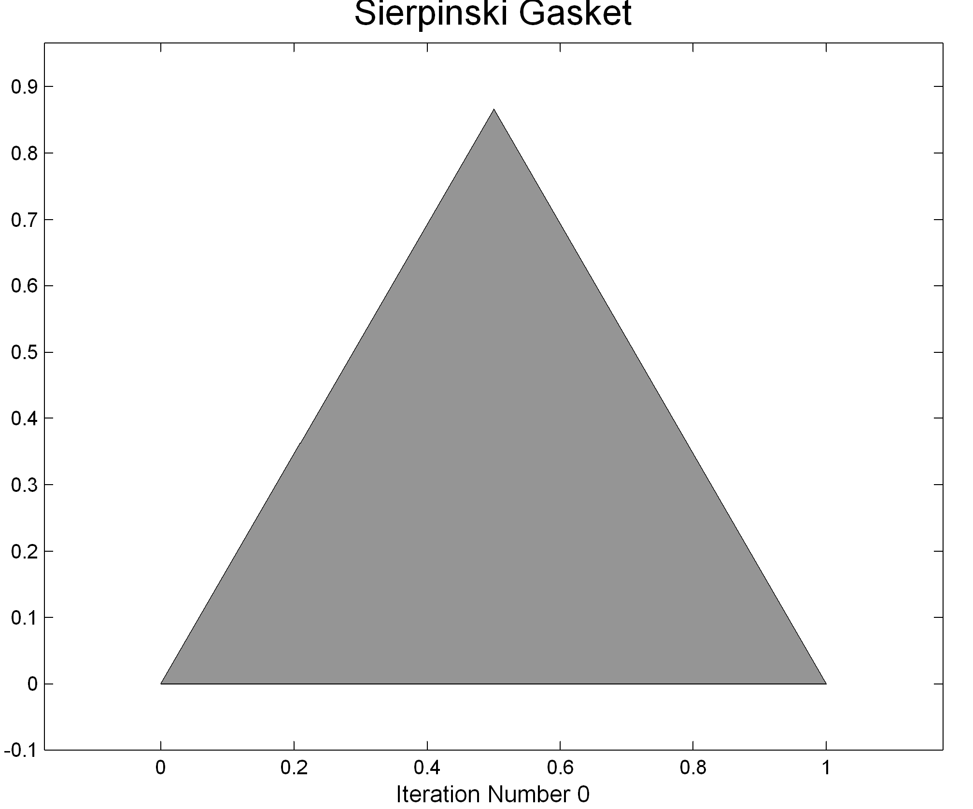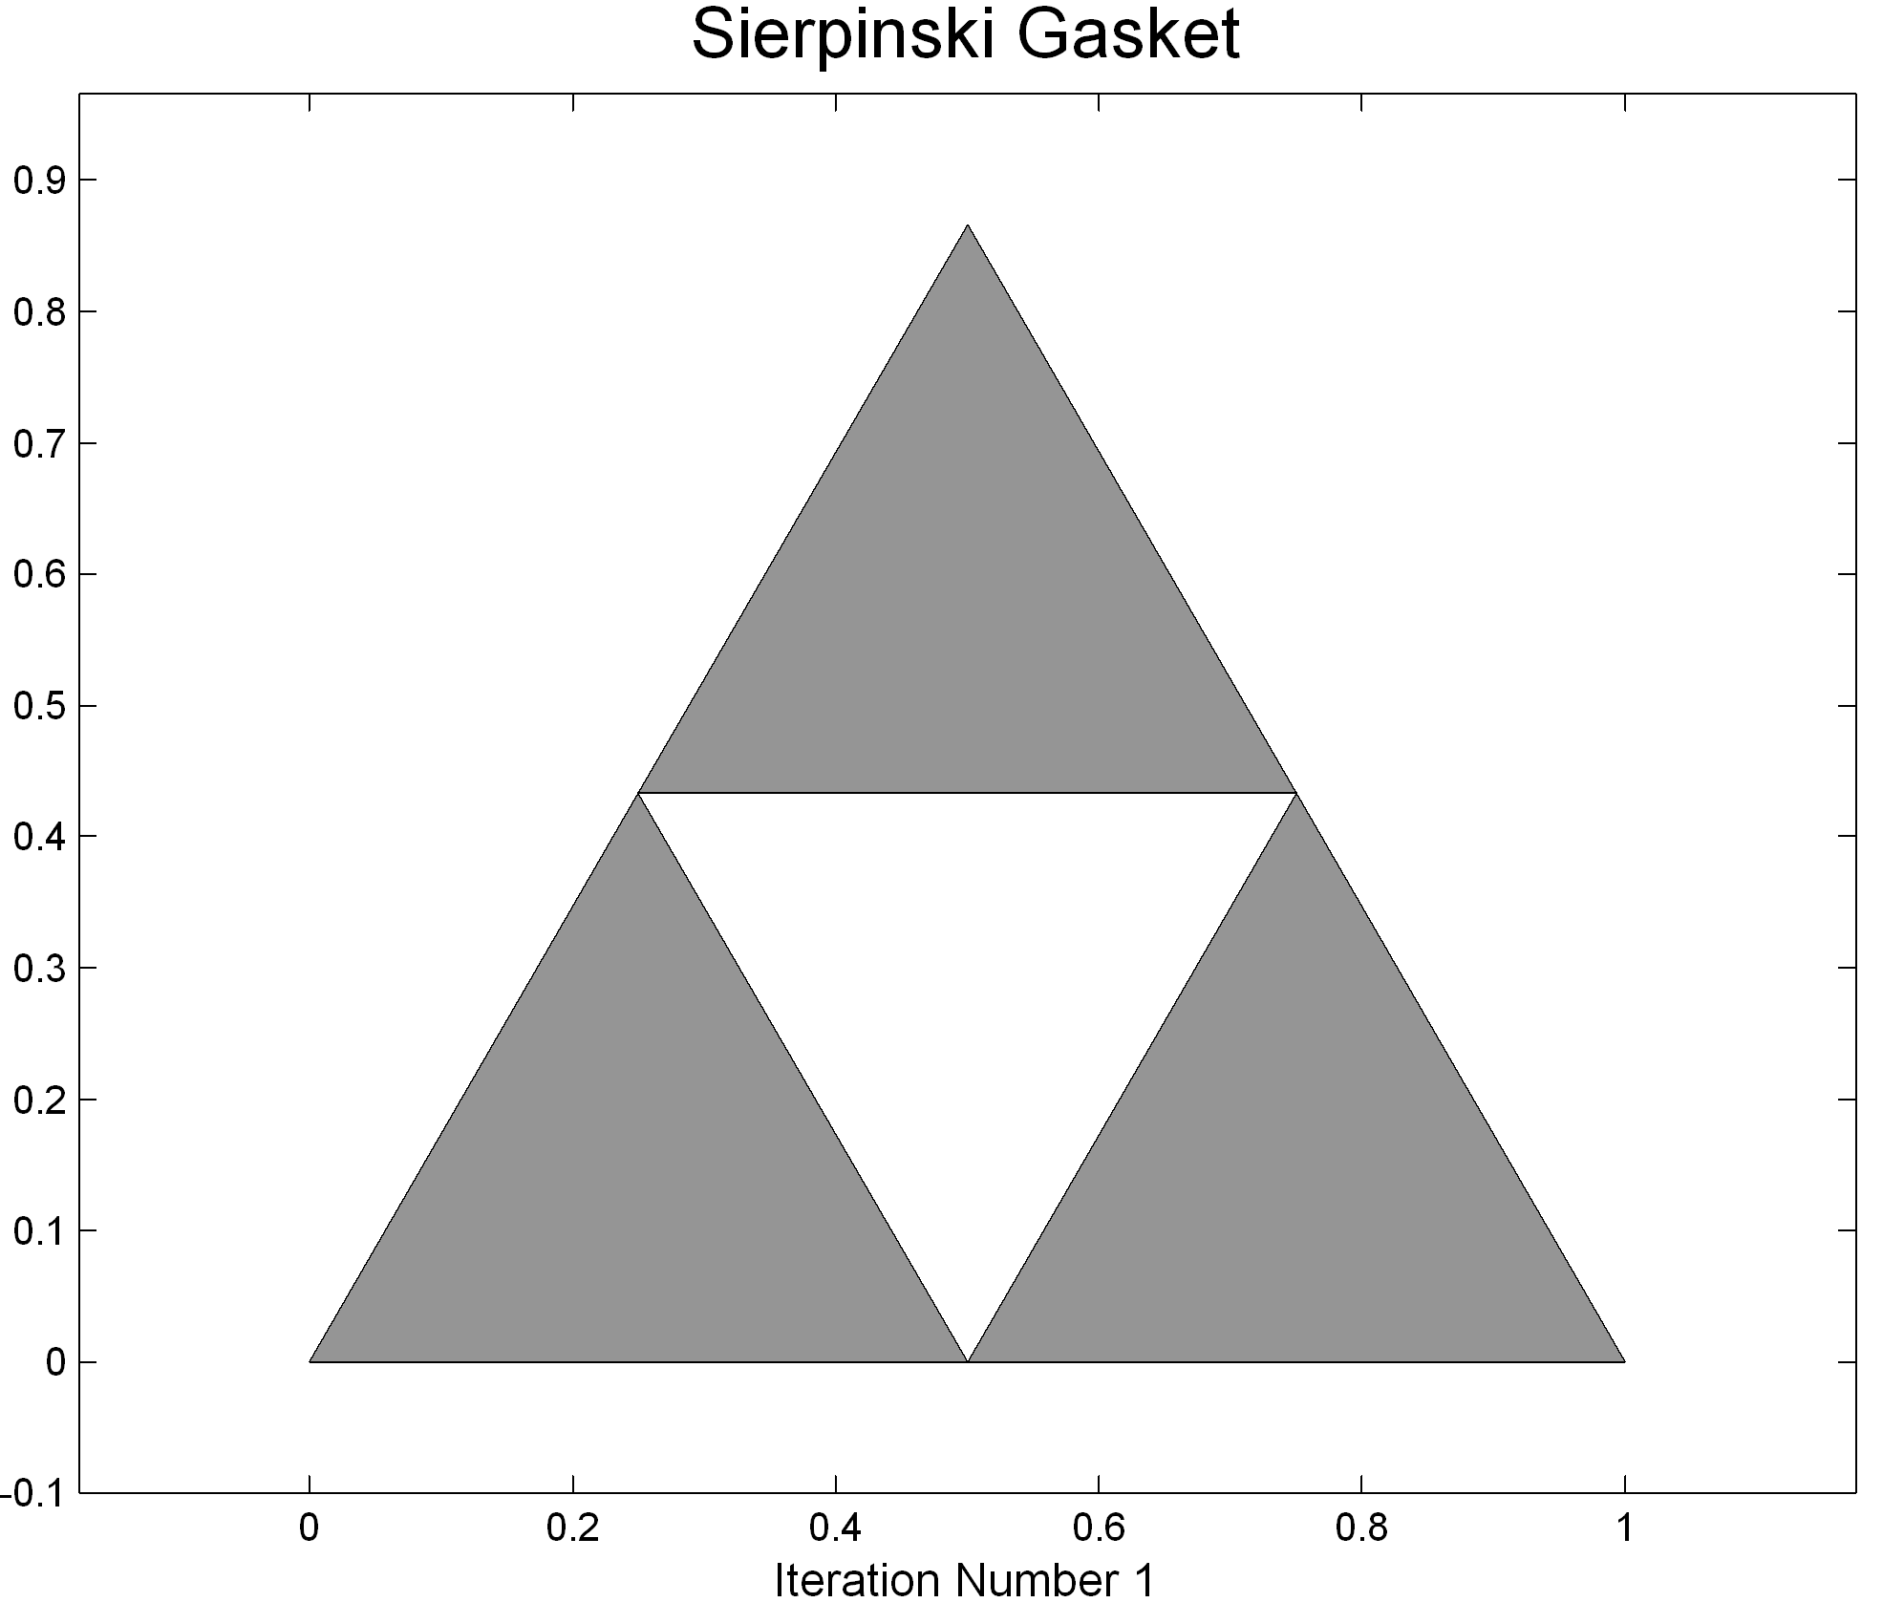

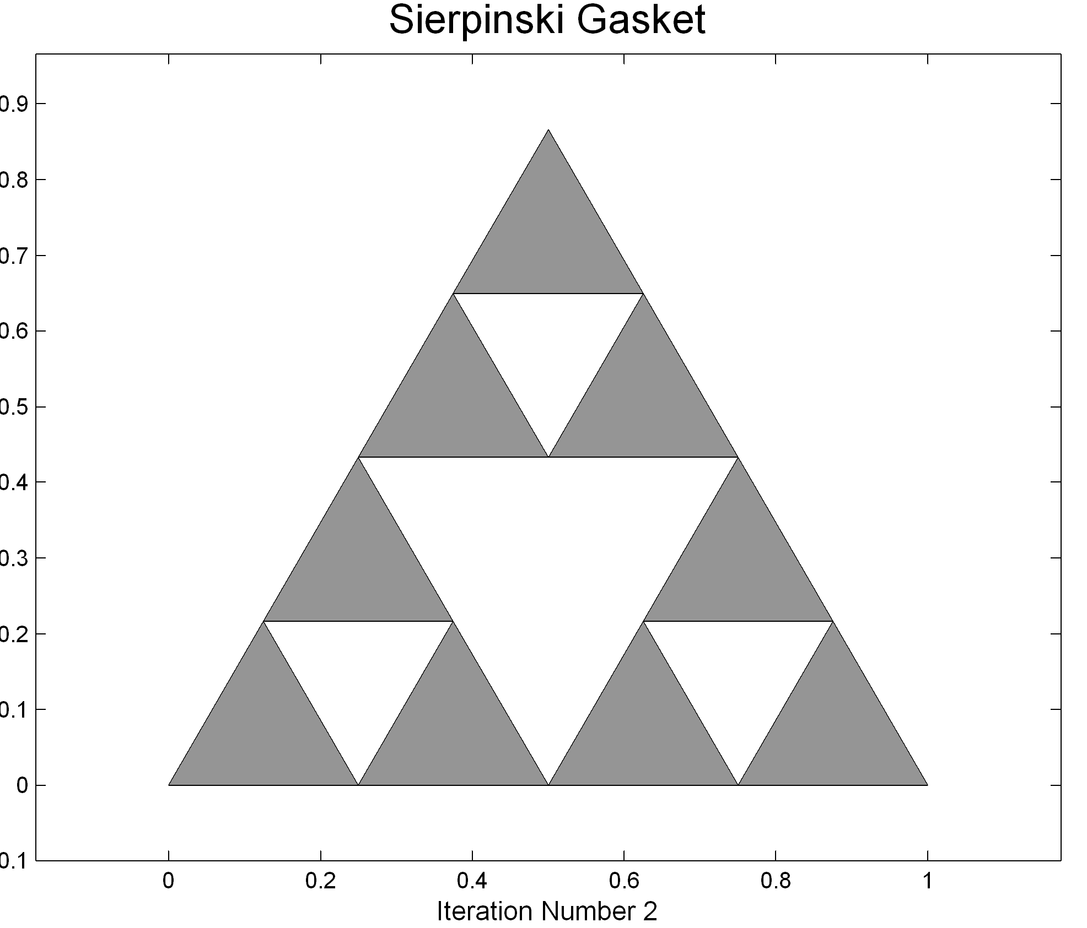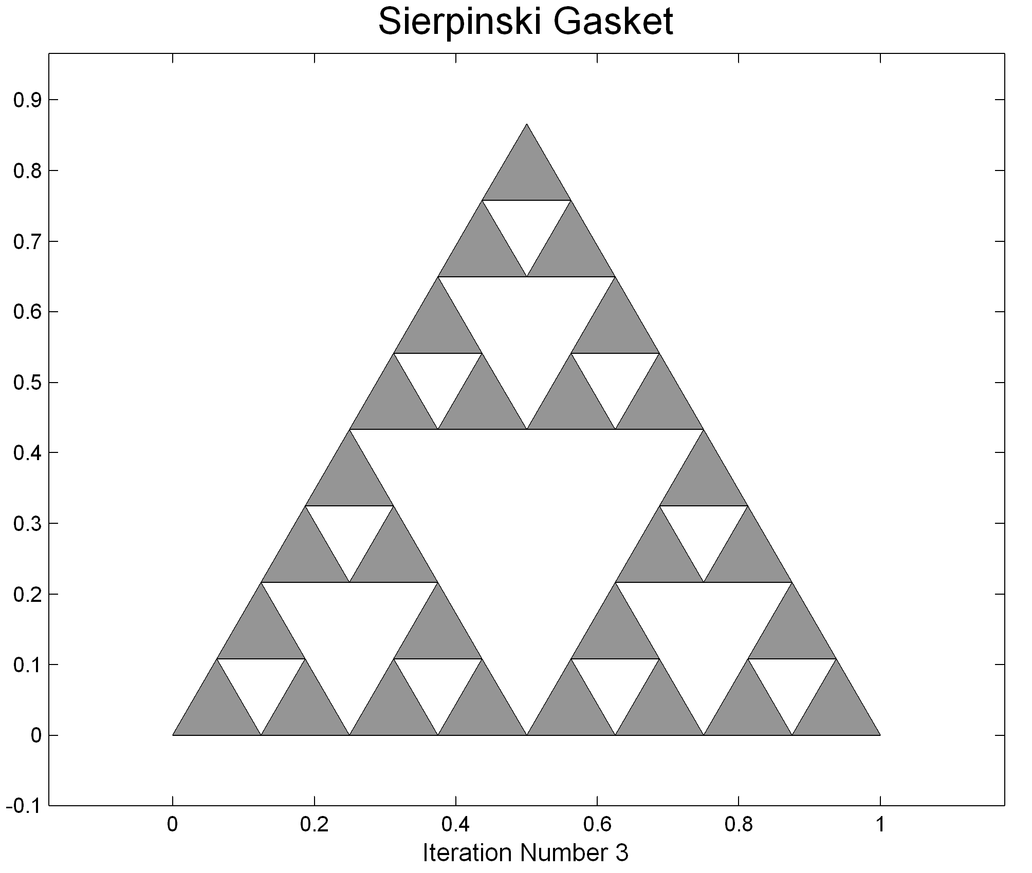

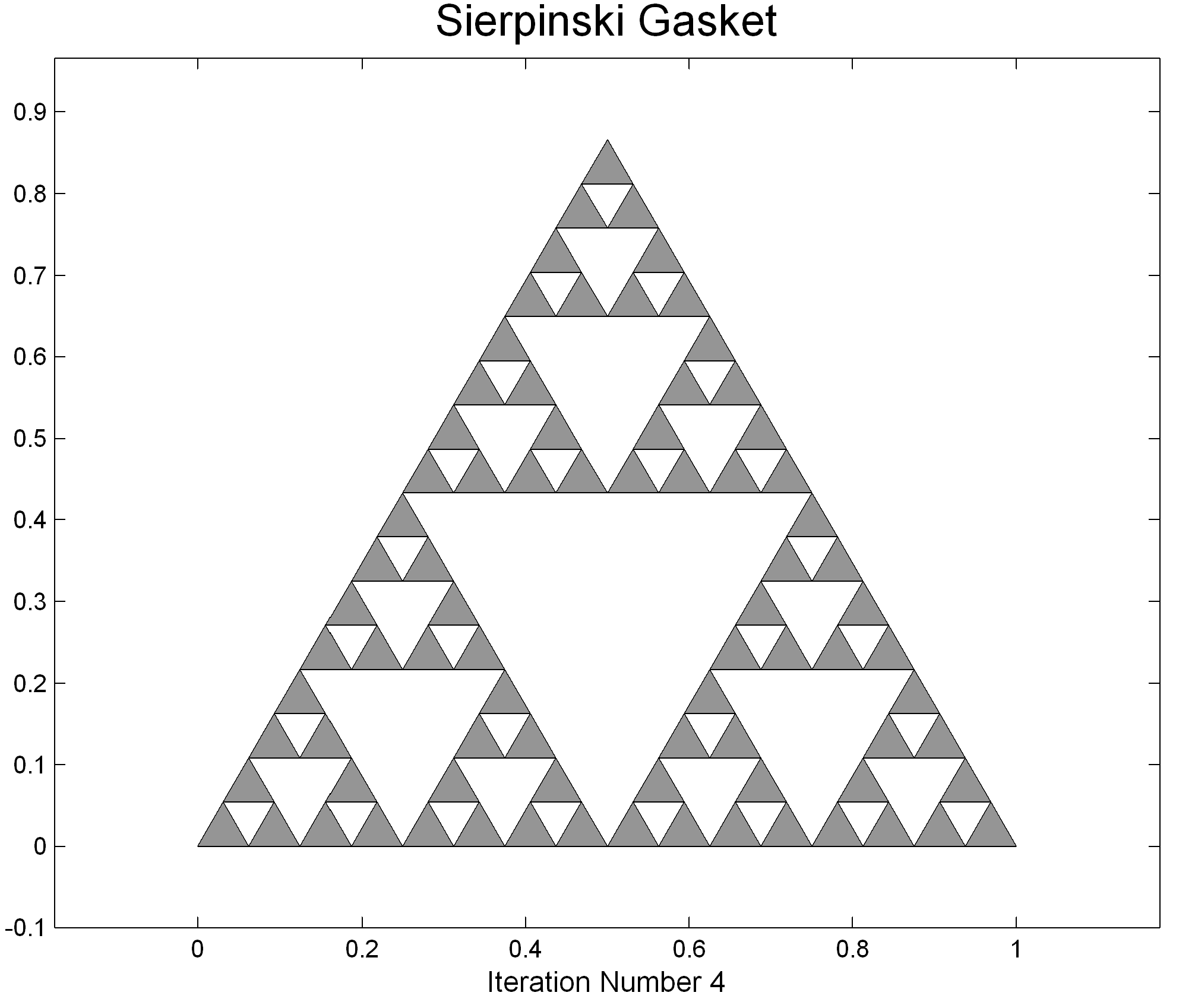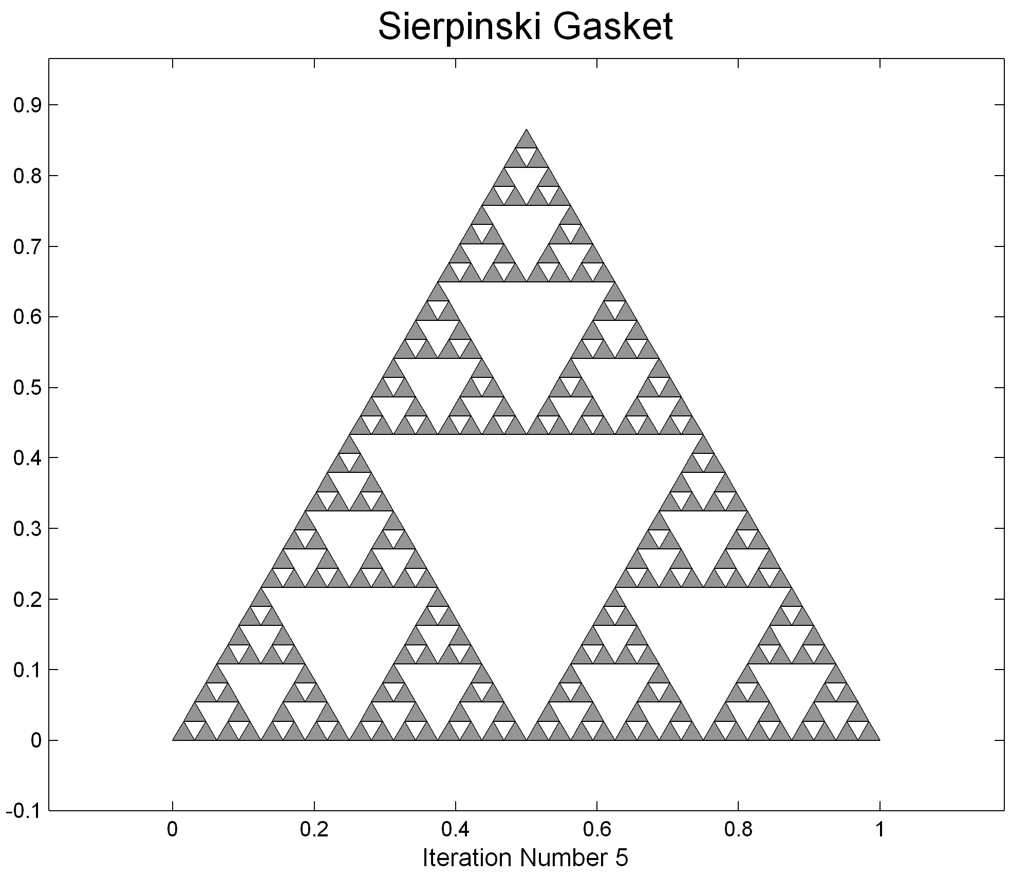

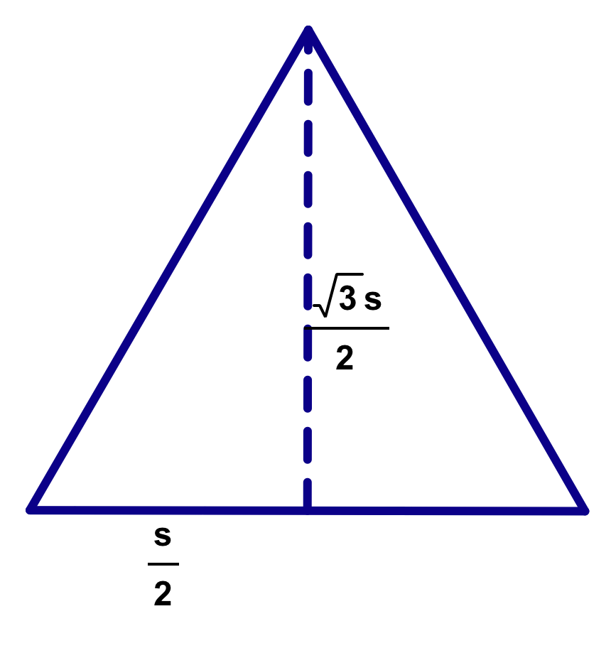

Let's calculate the area of the Sierpinski gasket. To do that, we will use the formula for the area of an equilateral triangle. The area of an equilateral triangle with sides of length s is: Here is a table listing the area remaining after each iteration.

n | No. Triangles Remaining | Length of Side | Area of Each Triangle | Total Area Remaining
0 | 1 | 1
1 | 3
2 | 9
3 | 27
n

Thus, the limiting value of the area remaining is 0. The Sierpinski Gasket has no area!

The Sierpinski gasket is the collection of points that remain after an infinite number of iterations: 0, 1, 2 . Let's denote this set of points by S. If the collection of points that remain after iteration number n is denoted by S_{n}, then Just as in the case of the Sumerian iteration for square roots, S is not equal to the set of points remaining after any one iteration, but is rather the limit of these sets, S_{n}. The following equation characterizes the Sierpinski gasket: Although the Sierpinski gasket has no area, it nonetheless contains infinitely many points.

The next fractal we consider is the Cantor set. This set is perhaps the oldest fractal. It was first published by the German mathematician Georg Cantor (1845-1918) in 1883. Although it is one of the simpler fractals, it is not so easy to visualize because it is a subset of the line rather than the plane.

The Cantor set is also obtained as the limit of an iterative process. The process begins with the closed unit interval on the number line, i.e. The first step of the iteration removes the middle third of the interval [0,1]. That is, all the points in the open interval (1/3,2/3) are removed, but not the endpoints 1/3 and 2/3. Thus, there are two closed intervals remaining: [0,1/3] and [2/3, 1].
The Cantor Set
Iterations Number 0, 1, 2 and 3
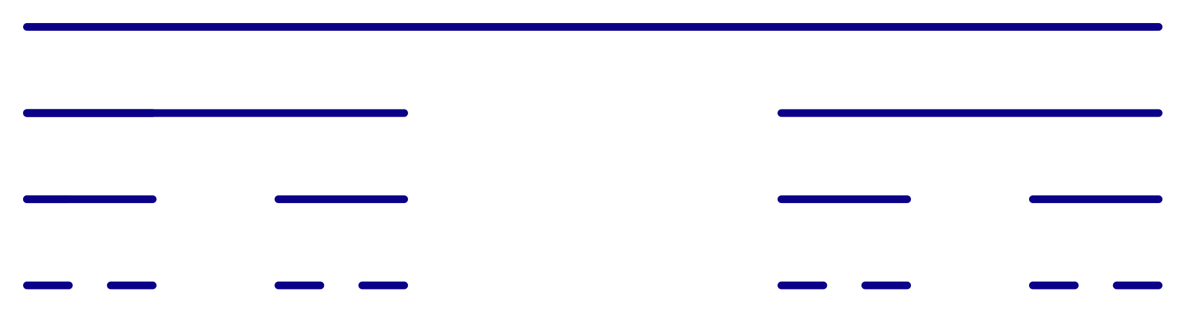

We continue by removing the middle third from each of the closed intervals remaining at each step.

The Cantor set is the collection of points that remain after an infinite number of iterations: 0, 1, 2 . Let's denote this set of points by C. Because this is a sparse subset of the number line, it is sometimes called Cantor dust. If the collection of points that remain after iteration number n is denoted by C_{n}, then Again, C is not equal to the set of points remaining after any iteration, but is rather the limit of this process that is the set points that belong to all of these sets:

Notice that the part of the Cantor set that lies in the interval [0,1/3] is simply a copy of the entire Cantor set multiplied by the scale factor 1/3. The same is true for the part in the interval [2/3,1]. This is the self-similarity property for this fractal.
How much of the unit interval does the Cantor set contain? Let's examine the length of the pieces that are thrown away. Here is a table listing for each iteration the total length of the intervals removed in that iteration and the total length of the intervals that remain after the iteration.

n | Removed | Remaining
0 | 0 | 1
1
2
3
4
n

Thus, in the limit, the entire length of the interval has been removed and the length of the Cantor set is 0.
Note that we can conclude from this table that
The last equation is a special case of the formula for the sum of the first terms of a geometric progression.
If , then the limiting form of this equation is
How many points are in C? Infinitely many, of course, since the end points of the closed intervals that occur are never removed. That is, the points all belong to C. On the other hand, C can not contain an interval [a,b] with a<b because if it did then it would have length at least b-a>0.

The next fractal we consider is based on the Cantor set and is called the Devil's Staircase. Again, it is constructed as the limit of an iterative process. We begin with the diagonal of the unit square, which we think of as the line segment joining the points (0,0) and (1,1) in the plane.

In the first iteration, we construct a stair step over the middle third of the x interval from [0,1] and 1/2 unit above the x-axis. The next iteration puts a stair step on each of the slanting portions at height 1/4 and 3/4 unit and width 1/9. We continue in this manner: On each slanting portion we place a stair step that is 1/3 as wide as the base of the slant portion and at a height that is half-way up the slant. The Devil's Staircase is the limiting curve that results for this construction. It divides the unit square into two congruent pieces. Also, it gives a continuous path from (0,0) to (1,1) that is monotonically rising from left to right. What is its length? To determine this we note that the n^{th} iterate produces a polygonal path with 2^{n} slant pieces that are all congruent and 2^{n-1} horizontal pieces. Here are the first three iterations
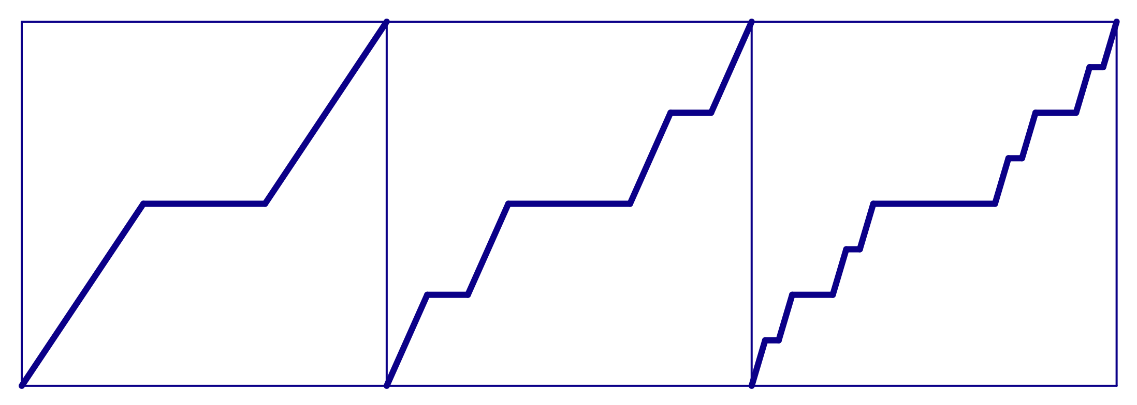
The table below gives the lengths of these pieces for various iterates.

n | Horizontal | Slant
0 | 0 | 1
1
2
3
n

In the limit the total length of the horizontal stair steps is 1, which is the same as the total length removed from the unit interval in the construction of the Cantor set. The total length of the slanting segments has a limiting value of 1 also. So we conclude that the length of the Devil's Staircase is 1+1=2.

We finish our presentation of the classical fractals with the beautiful snowflake curve of Helge von Koch. This curve was published in 1904 as an example of a continuous curve that has no tangent lines. Again, it is the limiting curve resulting from an iteration process. We start with an equilateral triangle with sides of length one. Each side of the triangle is divided into 3 equal parts. The middle piece on each side is replaced by an equilateral triangle with its base removed.

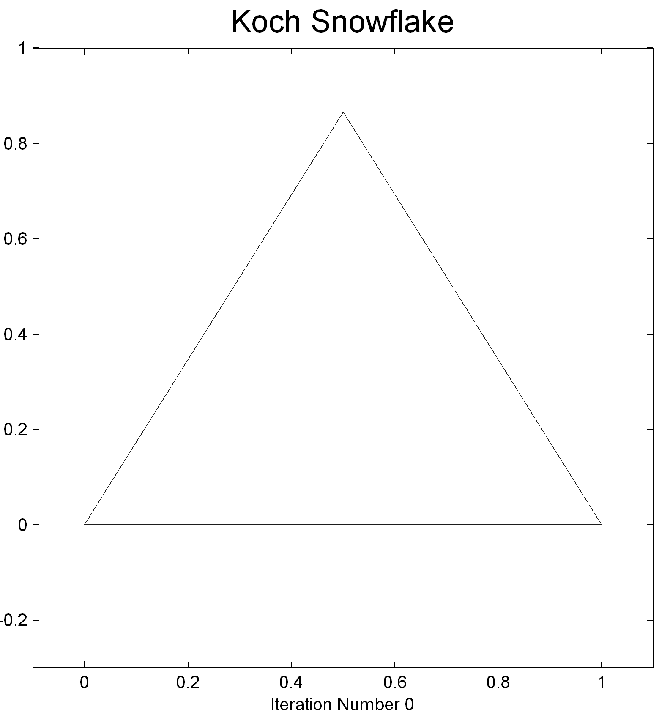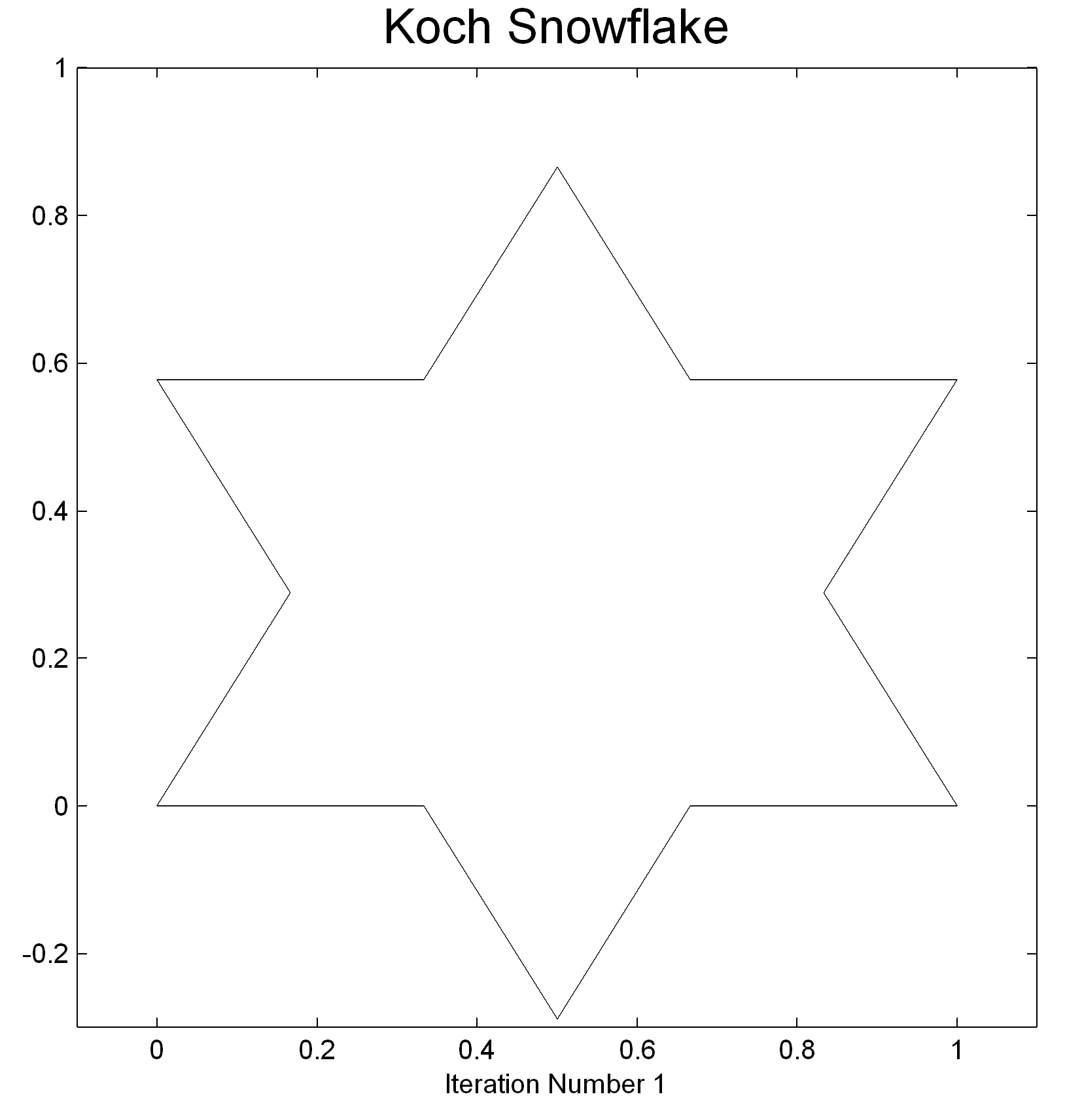

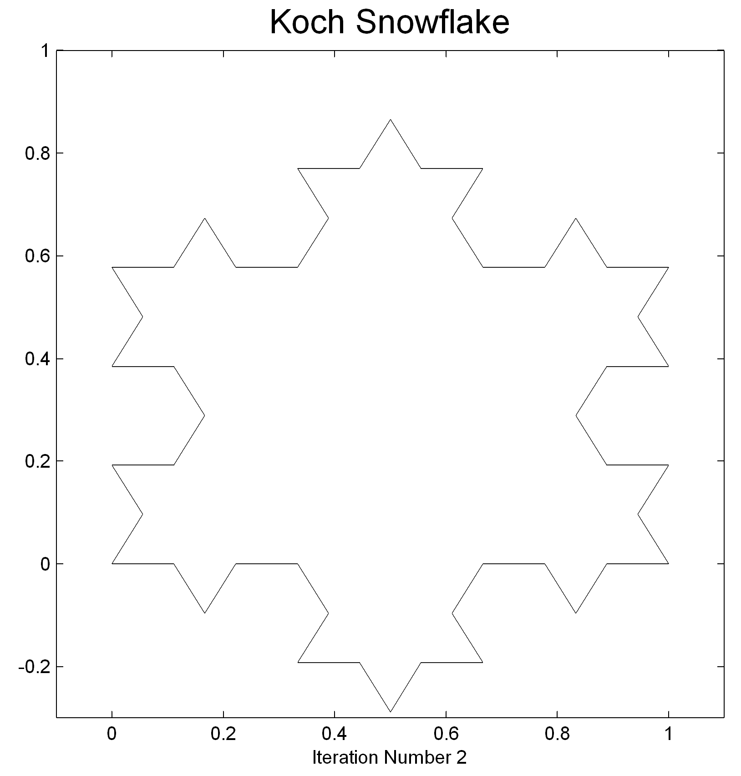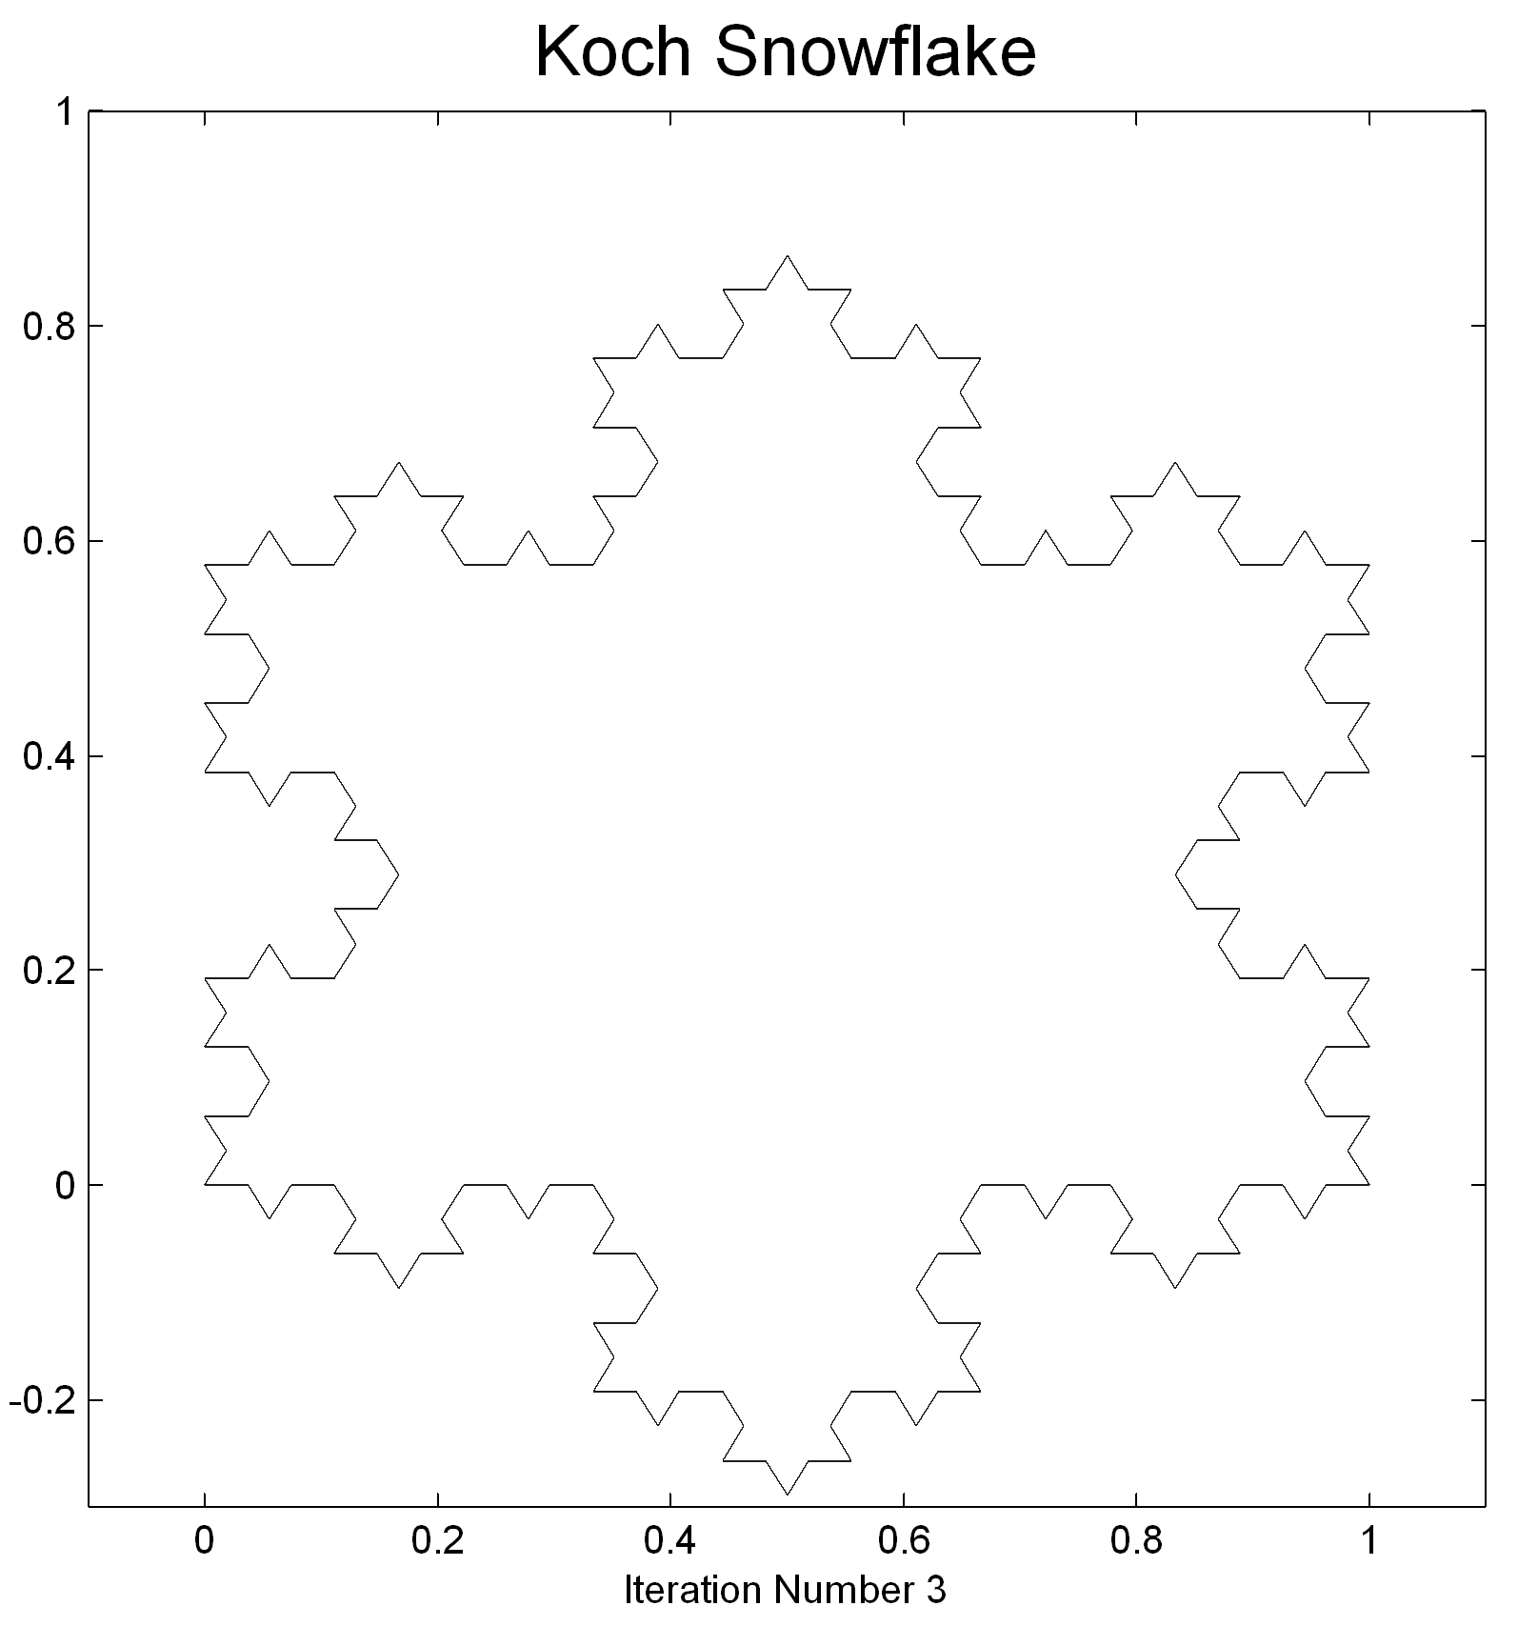

Let's find the length of the Koch Snowflake and the area of the region that it encloses. Here is a table listing various quantities after each iteration.

n | Number of Segments | Length of Segment | Total  Length | New Area
0 |  | 1 | 3
1 |  |  | 4
2
3

We see from the total length column that the lengths of the polygons that approximate the length of the Koch Snowflake curve grow larger and larger. Thus, the length of the Snowflake curve is infinite!

To find the area of the region bounded by the Snowflake curve, we add the entries in the last column. This sum can be written
The terms from the third to last are the sum of a geometric progression. Thus, the total sum is
In classical plane and solid geometry, lines, circles, and smooth curves have dimension 1. A square, a triangle, or a disk in a plane has dimension 2. A solid figure such as a cube or a sphere has dimension 3. This concept of dimension was extended in 1918 by the German mathematician Felix Hausdorff to more irregular sets. For the common geometrical shapes occurring in mathematics, physics and other areas, the Hausdorff dimension is a positive integer and agrees with the classical concept of dimension. However, for many fractals the Hausdorff dimension is not an integer.

Here is a table of the Hausdorff dimension of the fractals we've discussed.

Fractal | Hausdorff Dimension
Sierpinski Gasket
Cantor Set
Devil's Staircase | 1
Koch Snowflake

Mandelbrot argued that many shapes found in nature were fractals with non-integer dimension. He asserted that clouds are not spheres, mountains are not cones, coastlines are not circles, and barks is not smooth, nor does lightning travel in a straight line.
When randomness is introduced in the construction of fractals, one obtains shapes that look very natural. Here is a rough example of a fractal mountain.

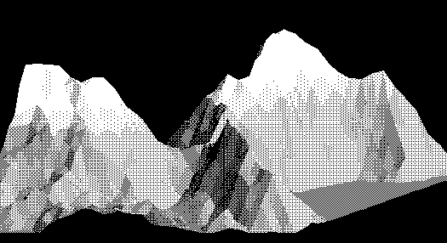
References

Mandelbrot, B. The Fractal Geometry of Nature, W. H. Freeman and Co., New York, 1983

Peitgen, H.-O., J"urgens, H., and Saupe, D., Fractals in the Classroom, Spring-Verlag, 1992

Peitgen, H.-O, J"urgens, H., and Saupe, D., Fractals for the Classroom: Strategic Activities Volumes One and Two, Springer-Verlag, 1991

Fractal Websites

Fractals in Nature

http://webecoist.com/2008/09/07/17-amazing-examples-of-fractals-in-nature/
http://library.thinkquest.org/26242/full/ap/ap11.html

Fractal Images and Videos

http://math.bu.edu/DYSYS/movies.html

See the zooming Sierpinski and look at Fibonacci Sequence and the Mandelbrot Set
http://storm.shodor.org/eoe/mandy/index.html

Zoom into Mandelbrot
http://www.ecometry.biz/patterns/htm

Hands on Fractals

http://www.ph.biu.ac.il/~rapaport/java-apps/lsys.html
See first iterations of various fractals

http://math.bu.edu/DYSYS/applets/fractalina.html
Attractors create Fractals

http://math.bu.edu/DYSYS/applets/chaos-game.html
Game that gives intuition about creating the Sierpinski Gasket

http://math.bu.edu/DYSYS/applets/linear-web.html
Linear Fractals

Learning Tools

http://aleph0.clarku.edu/~djoyce/julia/explorer.html
Explains Julia and Mandelbrot set well

http://local.wasp.uwa.edu.au/~pbourke/fractals/fracintro/
An intro to many aspects of fractals

http://math.bu.edu/DYSYS/explorer/
Activities, self-exploration. Could be a teaching site for more advanced students

http://serendip.brynmawr.edu/complexity/sierpinski.html
Explains Sierpinski Gasket, different ways to construct

Teaching Tools

http://math.rice.edu/~lanius/frac/

Lessons for Elementary and Middle School

http://mathforum.org/te/exchange/hosted/lee/lessons.html
http://math.bu.edu/DYSYS/chaos-game/chaos-game.html \\

Chaos in the Classroom And Art!

http://phys.unsw.edu.au/phys$\underline{\ }$about/PHYSICS/FRACTAL$\underline{\ }EXPRESSIONISM/fractal$\underline{\ }taylor.html
Jackson Pollock's art and its relation to fractals.

