ENRICHMENT PROJECT #8
MARGINAL FUNCTIONS & SUCESSIVE DIFFERENCES

Abstract: The method of successive differences for find the formula for the nth term of a sequence is developed and eventually justified. In addition, these activities will help students see the relationship between the degree of a polynomial and the differences of that polynomial. Building a strong understanding of rates of change will help students later on in Calculus.

Format: We start with a description of the project as presented to the students – including instructions, explanations and comments by the teacher. A set of Worksheet Templates is then appended to the end.

THE MARGINAL FUNCTION OF A FUNCTION

Suppose that you run a small manufacturing company that produces widgets. Production costs often fall into two categories: fixed costs and variable or marginal costs. Examples of fixed costs include rent on the factory, equipment maintenance costs and many management costs; examples of variable costs include raw materials, equipment operating costs and most labor costs. Given the cost function c(n) for your company, the marginal cost at the production level of n widgets may be thought of as the additional cost of producing one more widget and can be computed by taking the difference
c(n+1)-c(n). We actually define a new function c*(n) = c(n+1)-c(n), called the marginal cost function. So if you are now producing n widgets, it will cost c*(n) to produce just one more. In the same way, businessmen define marginal revenue, r*(n), and marginal profit p*(n), where r(n) and p(n) denote the revenue and profit functions. In general, the marginal functions are simpler and they do give us information about the original function. In this workshop we discuss some of the interesting and useful properties of the concept of marginal functions.

THE METHOD OF SUCESSIVE DIFFERENCES

We have just seen how the marginal function of a function arises in business. Another place that they arise is in the study of sequences of numbers and we will start our investigation there. Suppose that you have a sequence of numbers a₁, a₂, a₃,…,a_{n},… The natural question to ask is: are these numbers given by a function? That is can we find a function f(x), where a_{n} = f(n)? One of the tools that is often used to investigate such sequences is the computation of the differences, a new sequence consisting of successive difference of the original sequence: d₁=a₂-a₁, d₂=a₃-a₂,…,d_{n}=a_{(n+1)}-a_{n},… If the original sequence is given by a function f(x) then the successive difference sequence is given by its simpler marginal function f*(x). On the first few worksheets, we look at the successive difference and the marginal functions for a few simple functions.

Worksheet #1.

a) Fill out the rest of the chart using .

x |  | First Differences
1 | 4
1 | 4 | 1
2 | 5 | 1
2 | 5 | 1
3 | 6 | 1
3 | 6 | 1
4 | 7 | 1
4 | 7 | 1
5 | 8 | 1
Compute the marginal function for

b) Fill out the rest of the chart using .

x |  | First Differences
1 | 1
1 | 1 | 2
2 | 3 | 2
2 | 3 | 2
3 | 5 | 2
3 | 5 | 2
4 | 7 | 2
4 | 7 | 2
5 | 9 | 2

Compute the marginal function for

Worksheet #1 continued
c) Fill out the rest of the chart using .

x |  | 1st Differences | 2nd Differences
1 | 4
1 | 4 | 5
2 | 9 | 5 | 2
2 | 9 | 7 | 2
3 | 16 | 7 | 2
3 | 16 | 9 | 2
4 | 25 | 9 | 2
4 | 25 | 11 | 2
5 | 36 | 11

Compute the marginal functions f* and f** for

d) Fill out the rest of the chart using .

x |  | 1st Differences | 2nd Differences
1 | 1
1 | 1 | 6
2 | 7 | 6 | 4
2 | 7 | 10 | 4
3 | 17 | 10 | 4
3 | 17 | 14 | 4
4 | 31 | 14 | 4
4 | 31 | 18 | 4
5 | 49 | 18
Compute the marginal functions f* and f** for

Worksheet #1 continued
e) Fill out the rest of the chart using .

Compute all marginal functions for
x |  | 1st Differences | 2nd Differences | 3rd Differences
1 | 5
1 | 5 | 10
2 | 15 | 10 | 12
2 | 15 | 22 | 12 | 6
3 | 37 | 22 | 18 | 6
3 | 37 | 40 | 18 | 6
4 | 77 | 40 | 24 | 6
4 | 77 | 64 | 24
5 | 141 | 64

f) Fill out the rest of the chart using .

Compute all marginal functions for
x |  | 1st Differences | 2nd  Differences | 3rd Differences
1 | 4
1 | 4 | 7
2 | 11 | 7 | 12
2 | 11 | 19 | 12 | 6
3 | 30 | 19 | 18 | 6
3 | 30 | 37 | 18 | 6
4 | 67 | 37 | 24 | 6
4 | 67 | 61 | 24
5 | 128 | 61

It should be clear from this worksheet that the marginal function of a polynomial of degree k is a polynomial of degree k-1. Hence the kth differences are a constant. It is not at all difficult to give formal proofs of these facts; but the proofs can be notational nightmares. However, the following informal proof is easy to present. Simply observe that when computing the marginal function of a degree-k polynomial, the kth degree terms cancel out but the (k-1) degree terms do not leaving a polynomial of degree k-1.

To see how this works consider the sequence of sums of the first n squares: a₁=1, a₂=5 (1 + 4), a₃=14 (1 + 4 + 9), a₄=30 (1 + 4 + 9 + 16), a₅=55 (1 + 4 + 9 + 16 +25), and so on. Some time the successive differences are represented by lists forming an inverted pyramid:
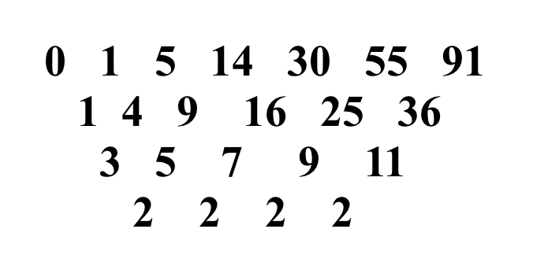

Here we have started with a₀ = 0, the sum of the first zero squares. The first differences are the squares the second differences are the odd numbers and the third differences are constant. If our theory is correct the sequence of partial sums of the squares should be given by a cubic polynomial. Knowing that it is given by cubic polynomial, we can easily compute its coefficients. Let p(n)=An³+Bn²+Cn+D be the polynomial.

Evaluating at 0, gives p(0)=A0+B0+C0+D and p(0)=a₀=0; so D=0 and p(n)=An³+Bn²+Cn.

Evaluating at 1, gives p(1)=A1+B1+C1 and p(1)=a₁=1; so A+B+C=1.

Evaluating at 2, gives p(2)=A8+B4+C2 and p(1)=a₁=1; so 8A+4B+2C=5.

Evaluating at 3, gives p(3)=A27+B9+C3 and p(1)=a₁=1; so 27A+9B+3C=14.

Solving this system of 3 linear equations in three unknowns gives

So We can now check this by evaluating the polynomial at 4, 5 and 6 and verifying that and .

Worksheet #2: Find the formula for the sums of the first n cubes.

a) Start with a₀=0, a₁=1, a₂=9, and compute a₃, a₄, a₅ and a₆.

a₃=1+8+27=36, a₄ =1+8+27+64=100, a₅=1+8+27+64+125=225 and a₆=1+8+27+64+125+216=441

b) Make a table of the 1st, 2nd , … as many differences as needed to get constant differences. Assuming that the partial sums of the cubes is given by a polynomial, what degree will it have?
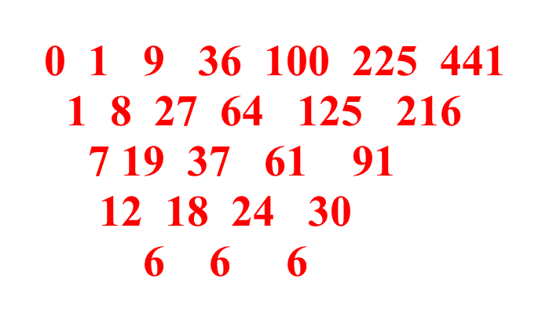

c) Write down the polynomial of this degree with undetermined coefficients and evaluate it at enough points to get a system of linear equations that can be solved.

gives
gives
gives
gives or
gives or

d) Solve the system and give the polynomial.

giving

e) Check that it gives the remaining values that you have computed.

and

As we discussed above, it is not difficult to verify that the kth differences of a polynomial of degree k are constant. But it is not obvious nor easy to justify that if a function defined on the integers has constant kth differences then it is a polynomial of degree k. We were only able to show that the sums of the squares [or cubes] might be given by However, once we have guessed these formulas, we can easily prove them by induction. We will leave the actual verification that the method of successive differences always works to the last “advanced” section of this workshop. While at this point we may not be able to be sure that a sequence is given by a polynomial, we can be sure that it is not given by a polynomial if the successive differences never become constant. We explore this fact on the next worksheet.

Worksheet $3.
a) One class of non-polynomial functions are the exponential functions. Let a₀=2⁰=1, a₁=2¹=2, a₂=2²=4,…,a_{n}=2^{n},… Construct the inverted pyramid for a₀ to a⁹.

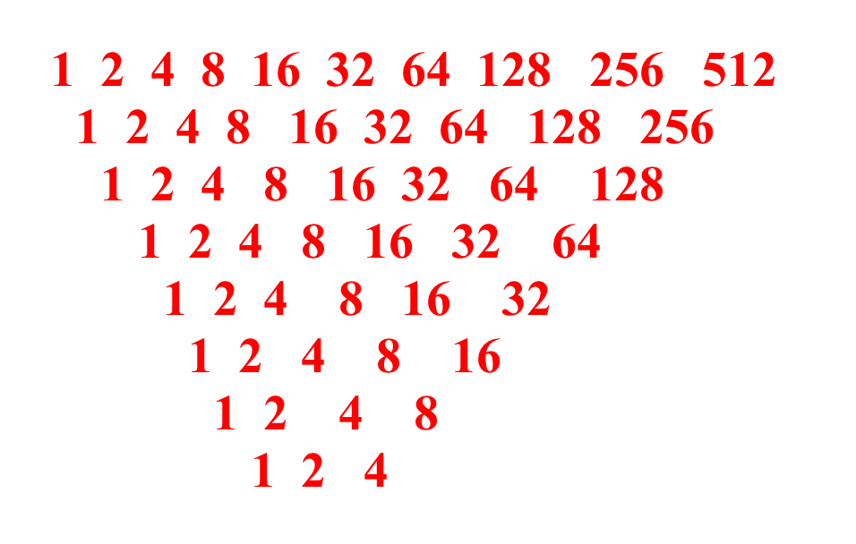
Will the successive differences ever become constant? Explain.
No, the successive differences are also the powers of 2: d_{n}=a^{(n+1)}-a_{n}=2^{n+1}-2^{n}=2^{n}

b) Another very famous sequence is the Fibonacci sequence: a₀=1, a₁=1 and a_{n}=a_{(n-1)} +a_{(n-2)}, for all n>1. So a₂=1+1=2, a₃=1+2=3, a₄=2+3=5, and so on. Investigate the Fibonacci sequence using the method of successive differences. What can you conclude?
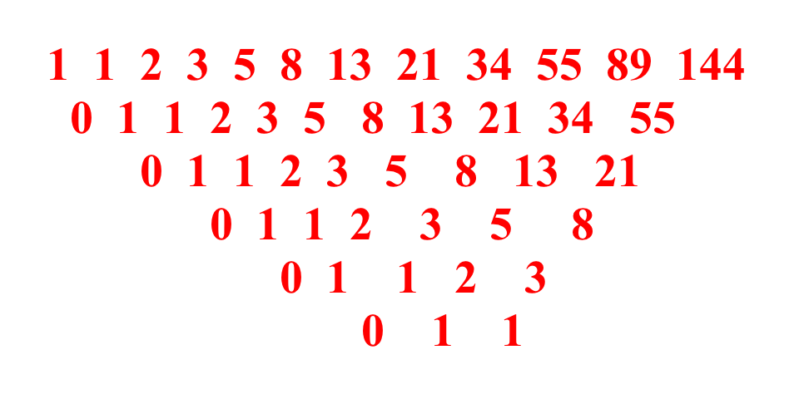

a_{n+1}=a_{n}+a_{n-1}; so d_{n}= a_{n+1}-a_{n}=a_{n-1}. Hence, we conclude that there is no polynomial formula for the Fibonacci sequence; in fact they seem to have the growth property of an exponential function.
We now continue our investigation of marginal function using business applications for examples. Recall that our small manufacturing company that produces widgets. Let’s assume that the cost function is a linear function c(q)=101.50q+755,000, where q is the quantity produced, $101.50 is the marginal cost and $755,000 the fixed costs. Let us compute the marginal revenue and marginal profit for our small appliance manufacturer. Revenue is simply price times quantity sold. If q items are put on the market in a given month, the price at which they will all sell is determined by the demand equation. We will assume a that the demand function is also simple linear function
Here p(q) denotes the price at which the widgets will sell if we produce q of them. This linear function has negative slope reflects the face that the more widgets that are available to lower the price. With this demand function, the revenue function is
In the following table we compute the revenue at several production levels:

quantity | 50,000 | 100,000 | 150,000 | 200,000 | 250,000
revenue | $7,000,000 | $12,000,000 | $15,000,000 | $16,000,000 | $15,000,000
Revenue seems to peak at about the production level of 200,000. We can verify this by considering the marginal revenue:
or , when rounded to the nearest cent. At q=100,000, we have a marginal revenue of $80. This means that by producing one more appliance, 100,001 in all, the revenue will increase by $80. At the $150,000 production level, the marginal revenue has dropped to $40, at q=200,000 it is zero and at q=250,000$ it is -$40. In this last case, the production of one mor4e widget will result in a lost of revenue. In general, if q < 200,000 and production is increased, revenue will increase, while if q > 200,000 and production is increased, revenue will decrease. Thus, revenue can be maximized by setting the production level at 200,000.

Now let's turn our attention to the profit function.

Worksheet #4. The profit function is defined to be revenue minus cost.

a) Recall that the revenue and cost functions are r(q)=-0.0004q²+160q and c(q)=101.50q+755,000 respectively. Compute the profit function P(q):

P(q) = r(q)- c(q) = -0.0004q²+160q-(101.50q+755,000) = -0.0004q²+58.50q-755,000

b) Add the profit function to this table

quantity | 50,000 | 100,000 | 150,000 | 200,000 | 250,000
revenue | $7,000,000 | $12,000,000 | $15,000,000 | $16,000,000 | $15,000,000
profit | $1,170,000 | $1,095,000 | -$980,000 | -$5,055,000 | -$11,130,000

c) Next compute the marginal profit function P*(q):

P*(q) = -0.0004(q+1)²+58.50(q+1)-755,000 –[-0.0004q²+58.50q-755,000]
= -0.0008q+58.5004.

d) Using the marginal find the production level that maximizes profit and compute the maximum profit.

-0.0008q+58.5004=0 at q=73,125.5. So profits can be increased by increasing production [P*(q)>0] when q<73,125.5 and profits will decrease if production is increased beyond that value [P*(q)<0 when q>73,125.5]. The maximum profit possible is $1,383,906.25 and that will occur when 73,125 appliances are produced.

When revenue is at its highest ($16,000,000 at q=200,000$), the company will have a loss of over $5,000,000. The reason for this is clear: at this production level the sale price of each appliance is only $80 while it cost slightly more than $101.50 to produce that appliance! Profit seems to peak when production is low. To find out exactly where profit is maximum we computed the marginal profit. The easy way to do this is to observe that since profit equals revenue minus cost, marginal profit equals marginal revenue minus marginal cost. We'll use this formula now and you will justify it later:
One easily checks that the cutoff production level is 73,125: if fewer than 73,125 appliances are produced, marginal profit is positive and producing another appliance will increase profit; while, if more than 73,125 appliances are produced, marginal profit is negative and producing one more appliance willdecrease profit. In this last case, producing one less appliance will usually increase profit. We conclude that the maximum profit possible is $1,383,906.25 and that will occur when 73,125 appliances are produced.

We close this workshop with exercises on the calculation and interpretation of marginal functions. The reader familiar with Calculus should be struck by the similarity between this ``calculus" (method of calculating) for marginal functions and the ``calculus" for derivatives.

Worksheet #5. Let g(n) and h(n) be two functions of the whole number variable n.

a) Show that, if then

b) Show that, if then and

The second formula follows from a different grouping.
c) Show that, if then

Worksheet #6.

Assume that all of the functions on this worksheet are functions of the whole number variable n.

a) Prove the following:
If f*=g* and f(1)=g(1) then f=g.

Sketch of the proof: We have and since f(1)=g(1), we may conclude that f(2)=g(2). Similarly, since f(2)=g(2), f(3)=g(3) and inductively f(n)=g(b), for all n.

b) Let f^{(k*)} denote the kth marginal function of f and prove the following:
.
Sketch of the proof:
and so on inductively.
c) Prove the following:
If f^{(k*)}=g^{(k*)} , f(1)=g(1), f(2)=g(2), …, f(k)=g(k), then f=g.

Sketch of the proof: This proof proceeds by induction on k, a) showed that the result holds for k=1. Assume then that the result holds for k-1. That is we assume that
f^{(k*)}=g^{(k*)} and f(1)=g(1), f(2)=g(2), …, f(k)=g(k). We have f^{(k*)}= f^{[(k-1)*]}* and g^{(k*)}= g^{[(k-1)*]}* and it follows from b) that f^{(k*)}(1)= g^{(k*)}(1). So by a) f^{[(k-1)*]}= g^{[(k-1)*]} and by induction f=g.

d) Prove the following:
If f^{(k*)} is a constant function, then f is a polynomial of degree k.
Sketch of the proof: By the method of undetermined coefficients, there is a unique degree k polynomial g(n) with g(1)=f(1), g(2)=f(2), …, g(k)=f(k); furthermore g^{(k*)} is a constant and equals f^{(k*)}. But then by c) f=g.

Worksheet #1.

a) Fill out the rest of the chart using .

x |  | First Differences
1

2

3
4

5

Compute the marginal function for

b) Fill out the rest of the chart using .

x |  | First Differences
1

2

3
4

5

Compute the marginal function for

Worksheet #1 continued
c) Fill out the rest of the chart using .

x |  | 1st Differences | 2nd Differences
1

2

3
4

5

Compute the marginal functions f* and f** for

d) Fill out the rest of the chart using .

x |  | 1st Differences | 2nd Differences
1

2

3
4

5

Compute the marginal functions f* and f** for

Worksheet #1 continued
e) Fill out the rest of the chart using .

Compute the marginal function for
x |  | 1st Differences | 2nd Differences | 3rd Differences
1

2

3
4

5

f) Fill out the rest of the chart using .

Compute the marginal function for
x |  | 1st Differences | 2nd  Differences | 3rd Differences
1

2

3
4

5

Worksheet #2. Find the formula for the sums of the first n cubes.
a) Start with a₀=0, a₁=1, a₂=9, and compute a₃, a₄, a₅ and a₆.

b) Make an inverted pyramid of the 1st, 2nd , … as many differences as needed to get constant differences. Assuming that the partial sums of the cubes is given by a polynomial, what degree will it have?

c) Write down the polynomial of this degree with undetermined coefficients and evaluate it at enough points to get a system of linear equations that can be solved

d) Solve the system and give the polynomial.

e) Check that it gives the remaining values that you have computed.

Worksheet $3.

a) One class of non-polynomial functions are the exponential functions. Let a₀=2⁰=1, a₁=2¹=2, a₂=2²=4,…,a_{n}=2^{n},… Construct the inverted pyramid for a₀ to a₉.

Will the successive differences ever become constant? Explain.

b) Another very famous sequence is the Fibonacci sequence: a₀=1, a₁=1 and a_{n}=a_{(n-1)} +a_{(n-2)}, for all n>1. So a₂=1+1=2, a₃=1+2=3, a₄=2+3=5, and so on. Investigate the Fibonacci sequence using the method of successive differences. What can you conclude?

Worksheet #4. The profit function is defined to be revenue minus cost.

a) Recall that the revenue and cost functions are r(q)=-0.0004q²+160q and c(q)=101.50q+755,000 respectively. Compute the profit function P(q):

b) Add the profit function to this table

quantity | 50,000 | 100,000 | 150,000 | 200,000 | 250,000
revenue | $7,000,000 | $12,000,000 | $15,000,000 | $16,000,000 | $15,000,000
profit

c) Now compute the marginal profit function P*(q):

d) Using the marginal find the production level that maximizes profit and compute the maximum profit.

Worksheet #5. Let g(n) and h(n) be two functions of the whole number variable n.

a) Show that, if then

b) Show that, if then and

c) Show that, if then

Worksheet #6.

Assume that all of the functions on this worksheet are functions of the whole number variable n.

a) Prove the following:
If f*=g* and f(1)=g(1) then f=g.

b) Let f^{(k*)} denote the kth marginal function of f and prove the following:
.

c) Prove the following:
If f^{(k*)}=g^{(k*)} , f(1)=g(1), f(2)=g(2), …, f(k)=g(k), then f=g.

d) Prove the following:
If f^{(k*)} is a constant function, then f is a polynomial of degree k.

